# R Exercises

1 . Use below data and create donut chart as shown in below figure.

data = c(179718,41370,41914,44280)

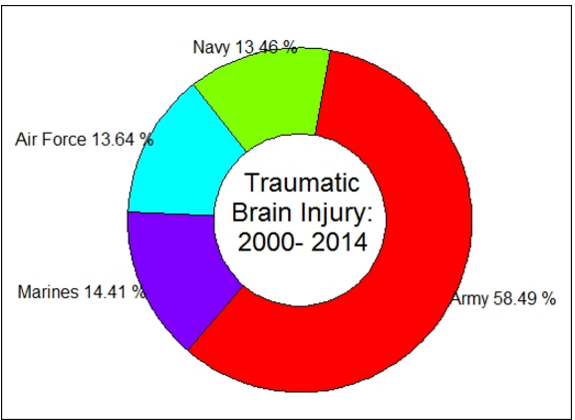

2. The Iraq body count is a database that maintains records of violent civilian deaths since 2003. The heat map clearly should show that the most civilian deaths occurred in the 2006-2008 period and it declined thereafter

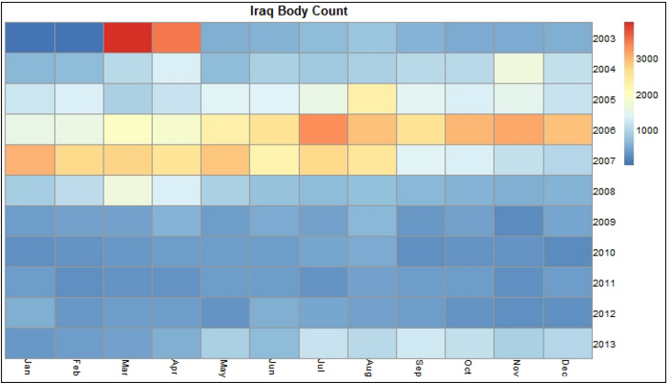

3. Generate a word cloud in R. A word cloud is simply a graphical representation in which the size of the font used for the word corresponds to its frequency relative to others. Bigger the size of the word, higher is its frequency.

Use below sentence for generating WordCloud

I also want to thank all the members of Congress and myadministration who are here today for the wonderful work that they do. I want to thank Mayor Gray and everyone here at THEARC for having me….